MODULE 2

Group Dynamics
- The social process by which people interact face-to-face in a small group is called group dynamics.
- The influences of personality, power and behavior on the group process.
- It focuses on team work wherein small groups are constantly in contact with each other and share common ideas to accomplish the given task.

- Types of groups

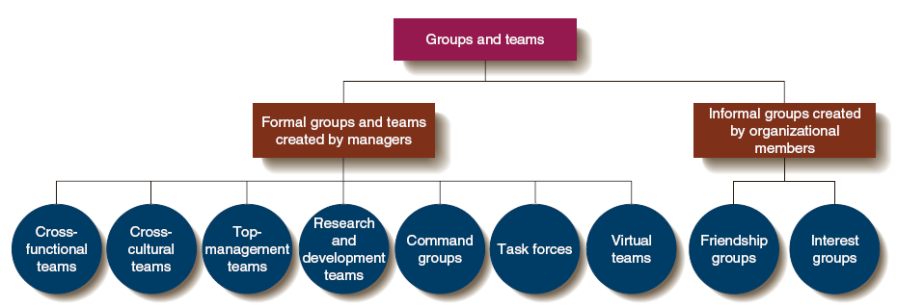
Group Dynamics: Interdependence
- Pooled-Members make separate, independent contributions to group such that group performance is the sum of each member’s contributions
- Sequential-Members perform tasks in a sequential order making it difficult to determine individual performance since one member depends on another
- Reciprocal-Work performed by one group member is mutually dependent on work done by other members 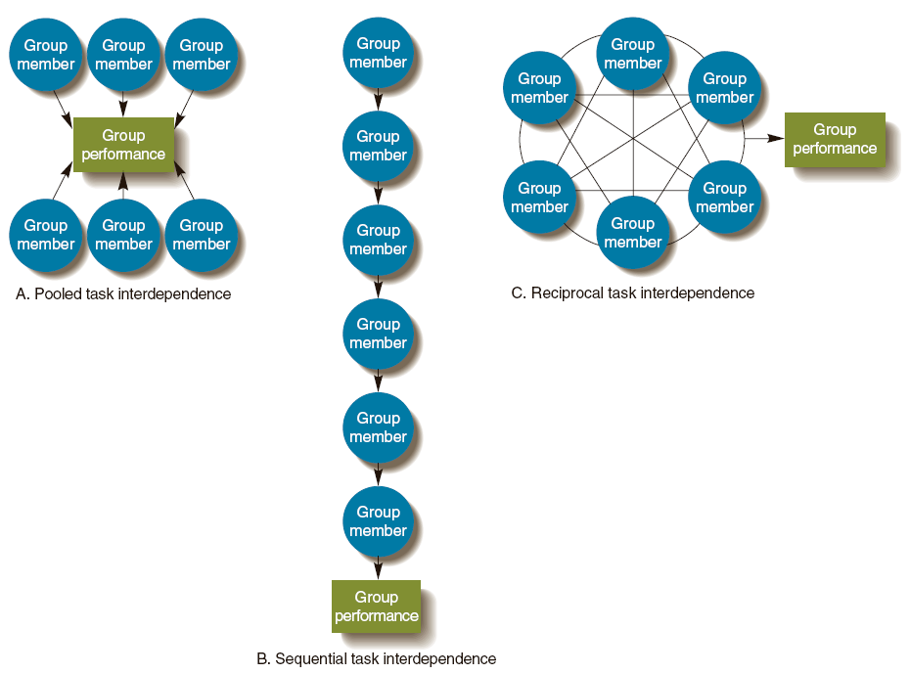
Group Behavior
- Group-Two or more individuals, interacting and interdependent, who come together to achieve particular objectives
- Formal groups - structured to perform specific tasks.
- Informal groups - emerge naturally in response to organizational or member interests.
- The Five-Stage Model of Group Development

Groups’ and Teams’ Contributions to Organizational Effectiveness
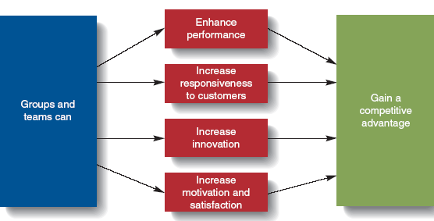
Group behavior/properties
1:Roles
The set of expected behavior patterns that are attributed to occupying a given position in a social unit
- Role Identity – role’s associated attitudes and behaviors
- Role Perception – our view of how we’re supposed to act in a given situation
- Role Expectations – how others believe you should act in a given situation
- Role Conflict – conflict experienced when multiple roles are incompatible

2: Norms
Acceptable standards of behavior within a group that are shared by the group’s members
- Powerful means of influencing behavior
- Performance Norms

3:Status
A socially defined position or rank given to groups or group members by others
- Determined by:
  - The power a person wields over others
  - A person’s ability to contribute to a group’s goals
  - An individual’s personal characteristics
4:Size
- Smaller groups are faster at completing tasks – members perform better
- Large groups are consistently better at problem solving

5: Cohesiveness
The degree to which members of the group are attracted to each other and motivated to stay in the group
- Performance-related norms are the moderating variable for productivity and cohesiveness
- High cohesiveness with high norms gives higher productivity

Communication
- Communication is an indispensable activity in all organization.
- No organization can think of its existence without effective communication
- Communication is a managerial skill which is essential for effective leading and motivation of people at work.
The Communication Process
  - Communication consists of two phases:
1. Transmission phase: information is shared by 2 or more people.
2. Feedback phase: a common understanding is assured.
  - Starts with the Sender who wants to share information.
    - Sender must decide on a message to share
    - Sender also puts the message into symbols or language, a process called encoding.

Noise: anything harming the communication process.

Message
Encoding
Medium
Decoding
Decoding
Medium
Encoding
Message
Receiver
(now sender)
Sender
Transmission Phase
Feedback Phase
NOISE

  - Messages are transmitted over a medium to a receiver.
    - Medium: pathway the message is transmitted on (phone, letter).
    - Receiver: person getting the message.
  - Receiver next decodes the message.
    - Decoding allows the receiver to understand the message.
    - This is a critical point, can lead to misunderstanding.
  - Feedback is started by receiver and states that the message is understood or that it must be re-sent.

Importance of Good Communication
- Good Communication allows a firm to
  - Learn new skills and technologies.
  - Become more responsive to customers.
  - Improve Quality of their product or service.
  - Foster innovation
- Effective communication is needed by all Managers.

Communication Media
High
Richness
Face-to-face
communication

Verbal communication
electronically
transmitted

Impersonal written
communication

Low
Richness

Personally Addressed Written Communication: lower richness than the verbal forms, but still is directed at a given person.
    - Personal addressing helps ensure receiver reads it.
      - Letters and e-mail are common forms.
    - Cannot provide instant feedback to sender but can get feedback later.
      - Excellent for complex messages needing follow-up.
Impersonal Written Communication: lowest richness.
    - Good for messages to many receivers. Little feedback is expected.
      - Newsletters, reports are examples.

Face-to-Face: highest information richness.
    - Can take advantage of verbal and nonverbal signals.
    - Provides for instant feedback.
      - Management by wandering around takes advantage of this with informal talks to workers.
    - Video Conferences: provide much of this richness.
      - Reduce travel costs and meeting times.
Verbal Communication electronically transmitted: has next highest richness.
    - Phone conversations, but no visual nonverbal cues.
      - Do have tone of voice, sender’s emphasis and quick feedback.

Face-to-Face
Face-to-face or personal communication is one of the richest channels of communication that can be used within an organization. Physical presence, the tone of the speaker's voice and facial expressions help recipients of a message interpret that message as the speaker intends. This is the best channel to use for complex or emotionally charged messages, because it allows for interaction between speaker and recipients to clarify ambiguity. A speaker can evaluate whether an audience has received his message as intended and ask or answer follow-up questions.

Broadcast Media
TV, radio and loud speakers all fall within the broadcast media communication channel. These types of media should be used when addressing a mass audience. Businesses seeking to notify customers of a new product may advertise or do promotions using a broadcast channel. Similarly, a CEO may do a global company address by having a television feed broadcast across global sites. When a message intended for a mass audience can be enhanced by being presented in a visual or auditory format, a broadcast channel should be used.

Mobile
A mobile communication channel should be used when a private or more complex message needs to be relayed to an individual or small group. A mobile channel allows for an interactive exchange and gives the recipient the added benefit of interpreting the speaker's tone along with the message. Some within an organization may opt to use this channel versus a face-to-face channel to save on the time and effort it would take to coordinate a face-to-face meeting.

Electronic
Electronic communication channels encompass email, Internet, intranet and social media platforms. This channel can be used for one-on-one, group or mass communication. It is a less personal method of communication but more efficient. When using this channel, care must be taken to craft messages with clarity and to avoid the use of sarcasm and innuendo unless the message specifically calls for it.

Written
Written communication should be used when a message that does not require interaction needs to be communicated to an employee or group. Policies, letters, memos, manuals, notices and announcements are all messages that work well for this channel. Recipients may follow up through an electronic or face-to-face channel if questions arise about a written message

E-Mail Trends
  - E-mail use is growing rapidly in large firms, and there are even special e-mail etiquette:
    - Words in all CAPITALS are seen as “screaming” at the receiver.
    - Punctuate your messages for easy reading and don’t ramble on.
    - Pay attention to spelling and treat like a written letter.
  - E-mail has allowed telecommuting, where workers can work from home and be in touch with e-mail.

Barriers to communication
- Barriers to communication cause break downs, distortions and inaccurate information.
- Whenever a communication is made, there is always a tendency on the part of the receiver to evaluate the message received and then decide to approve or disapprove the same.
The main barriers of communication are:
1. Barriers due to organization structure
2. Barriers due to relationship
3. Semantic barriers
4. Filtering of information
5. Perceptual errors
6. Closed mind
7. Lack of ability to communicate
8. Inattention
9. Resistance to change
10. Situational factors
11. Miscellaneous barriers
Channels of communication
Communication channels are the means through which people in an organization communicate. Thought must be given to what channels are used to complete various tasks, because using an inappropriate channel for a task or interaction can lead to negative consequences. Complex messages require richer channels of communication that facilitate interaction to ensure clarity.
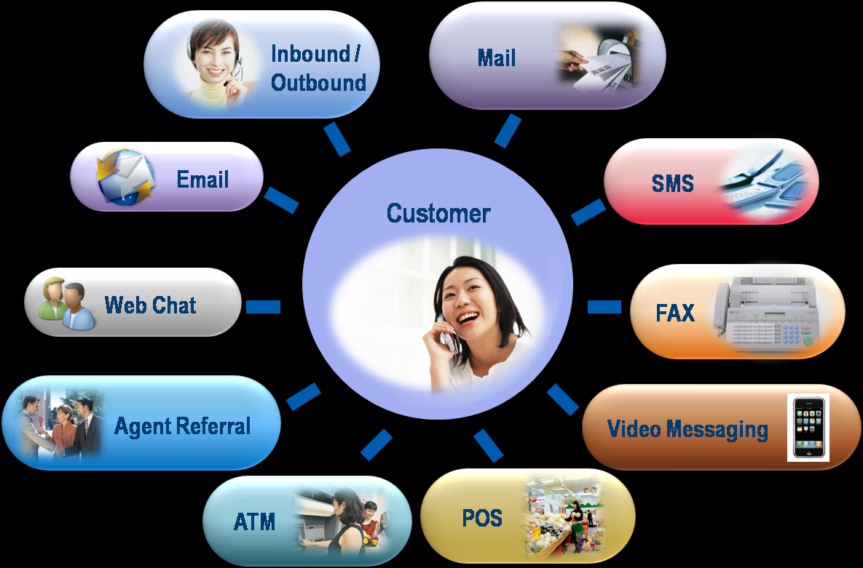

In an organization there are mainly four types of communication channels. They are:
- Vertical Communication
- Horizontal Communication
- Diagonal Communication
- Grapevine Communication
Vertical Communication
Vertical communication can be divided into two categories i.e. upward communication and downward communication.
Downward communication refers to communication that flows from the superior authority to the subordinate authority or from the higher level to the lower level. It is the most important direction of communication and the very nature of the organization. No organization can function without it. Downward communication is mostly used give instructions - written and spoken, letters, memorandum, policy matters, speeches, meeting, information etc.

Upward communication refers to communication that flows from the subordinate to the superior or from the lower level to the upper level. It is mainly used by employees to give feedback about various responsibilities and also to give suggestion about how the task was executed. It includes reports, proposals, suggestions, grievances, etc.

Horizontal Communication
When communication takes place between two or more persons who are subordinates working in the same section or department, it is called as horizontal communication. It is one of the most frequently used channels of communication to maintain coordination between people of the same section or level. In this process message flows not only up and down but also sideways. During such interactions the views of each other are made known and decisions are arrived quickly. Here we find no superior or subordinate relationship.

Diagonal Communication
It includes the horizontal flow of information as well as interaction across different levels of an organization’s hierarchy. Diagonal communication is used to speed up the flow of communication. It makes effective efforts for achieving organizational goals.

Grapevine Communication
Grapevine communication is a type of informal business communications which develops within an organization. It means gossip. Usually gossip that spreads and covers a lot of ground (a lot of people) like vines does. However there are disadvantages or limitations to grapevine communication. It has the potential to spread unnecessary gossips. It can be dangerous to the organization if allowed to grow without monitoring. It may result in character assassination and personal vilification of individuals. It may provoke sudden unwanted and unexpected reactions from emotionally unstable people. Grapevine channel can be moderated but not eliminated.

Flow patterns of Communication
•Information flows in an organization both formally and informally.
•The term formal refers to communication that follows the official hierarchy and is required to do one’s job.
•It flows through formal channels- the main lines of organizational communication
Internal operational and external operational communication can be described as formal.
•The bulk of communication that a business needs flows through these channels

For example,
A manager instructs a subordinate on some matter.
When two employees discuss a customer’s order or policy change.
This type of Communication can is downward, upward, lateral or diagonal.
nager3Manager3Manager2
Downward Communication
•Flows from a manager down the chain of command.
•When managers inform, instruct, advise, or request their subordinates.
•Generally used to convey routine information, new policies or procedures, to seek clarification, to ask for an analysis.
•Also, superiors send feedback about their subordinates through this channel.
•It increases awareness about the organization among subordinates and employees.

Lateral or Horizontal Communication…
•From the organization's point of view it can be advantageous or disadvantageous.
•At times vertical communication channels are bypassed by employees for personal gains.
•The Vice President (Marketing) sending some survey results to VP(Production)

Diagonal or Cross- wise communication
•Flows in all directions and cuts across functions and levels of communication.
•A sales manager communicates directly with the VP (Production)
•It is quick and efficient.

Diagonal or Cross- wise communication…
•At times it prevents employee’s being used just as a medium between sender and receiver.
•Increased used of e-mail also encourages cross- wise communication. It is also referred to as radical, circular communication.
Control

Definitions
In 1916, Henri Fayol formulated one of the first definitions of control as it pertains to management:
Control of an undertaking consists of seeing that everything is being carried out in accordance with the plan which has been adopted, the orders which have been given, and the principles which have been laid down. Its object is to point out mistakes in order that they may be rectified and prevented from recurring.
According to EFL Breach:
Control is checking current performance against pre-determined standards contained in the plans, with a view to ensure adequate progress and satisfactory performance.
According to Harold Koontz:
Controlling is the measurement and correction of performance in order to make sure that enterprise objectives and the plans devised to attain them are accomplished.
According to Stafford Beer:Management is the profession of control.
Robert J. Mockler presented a more comprehensive definition of managerial control:
Management control can be defined as a systematic effort by business management to compare performance to predetermined standards, plans, or objectives in order to determine whether performance is in line with these standards and presumably in order to take any remedial action required to see that human and other corporate resources are being used in the most effective and efficient way possible in achieving corporate objectives

Elements
The four basic elements in a control system:
- The characteristic or condition to be controlled
- The sensor
- The comparator
- The activator

Characteristics of control

- Control is a continuous process
- Control is a management process
- Control is embedded in each level of organizational hierarchy
- Control is forward looking
- Control is closely linked with planning
- Control is a tool for achieving organizational activities
- Control is an end process
- Control compares actual performance with planned performance*
- control point out the error in the execution process
- control helps in minimizing cost
- control helps in achieving standard
- control saves the time

Process of control
- Setting performance standards.
- Measurement of actual performance
- Comparing actual performance with standards.
- Analysis deviations.
- Taking corrective measures.

Kinds of control
Control may be grouped according to three general classifications
- The nature of the information flow designed into the system (open- or closed-loop control)
- The kind of components included in the design (man or machine control systems)
- The relationship of control to the decision process (organizational or operational control).

Open- and closed-loop control

A street-lighting system controlled by a timing device is an example of an open-loop system. At a certain time each evening, a mechanical device closes the circuit and energy flows through the electric lines to light the lamps. Note, however, that the timing mechanism is an independent unit and is not measuring the objective function of the lighting system. If the lights should be needed on a dark, stormy day the timing device would not recognize this need and therefore would not activate energy inputs. Corrective properties may sometimes be built into the controller (for example, to modify the time the lights are turned on as the days grow shorter or longer), but this would not close the loop. In another instance, the sensing, comparison, or adjustment may be made through action taken by an individual who is not part of the system. For example, the lights may be turned on by someone who happens to pass by and recognizes the need for additional light.

Man and machine control

The elements of control are easy to identify in machine systems. For example, the characteristic to be controlled might be some variable like speed or temperature, and the sensing device could be a speedometer or a thermometer. An expectation of precision exists because the characteristic is quantifiable and the standard and the normal variation to be expected can be described in exact terms. In automatic machine systems, inputs of information are used in a process of continual adjustment to achieve output specifications. When even a small variation from the standard occurs, the correction process begins. The automatic system is highly structured, designed to accept certain kinds of input and produce specific output, and programmed to regulate the transformation of inputs within a narrow range of variation

Organizational and operational control

The concept of organizational control is implicit in the bureaucratic theory of Max Weber. Associated with this theory are such concepts as "span of control", "closeness of supervision", and "hierarchical authority". Weber's view tends to include all levels or types of organizational control as being the same. More recently, writers have tended to differentiate the control process between that which emphasizes the nature of the organizational or systems design and that which deals with daily operations. To illustrate the difference, we "evaluate" the performance of a system to see how effective and efficient the design proved to be or to discover why it failed. In contrast, we operate and "control" the system with respect to the daily inputs of material, information, and energy. In both instances, the elements of feedback are present, but organizational control tends to review and evaluate the nature and arrangement of components in the system, whereas operational control tends to adjust the daily inputs.

Control techniques used for managerial control

1. Direct Supervision and Observation
Direct Supervision and Observation' is the oldest technique of controlling. The supervisor himself observes the employees and their work. This brings him in direct contact with the workers. So, many problems are solved during supervision. The supervisor gets firsthand information, and he has better understanding with the workers. This technique is most suitable for a small-sized business.
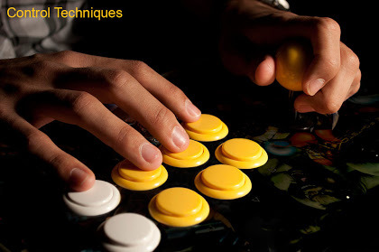

2. Financial Statements
All business organisations prepare Profit and Loss Account. It gives a summary of the income and expenses for a specified period. They also prepare Balance Sheet, which shows the financial position of the organisation at the end of the specified period. Financial statements are used to control the organization. The figures of the current year can be compared with the previous year's figures. They can also be compared with the figures of other similar organizations.
Ratio analysis can be used to find out and analyses the financial statements. Ratio analysis helps to understand the profitability, liquidity and solvency position of the business.

3. Budgetary Control
A budget is a planning and controlling device. Budgetary control is a technique of managerial control through budgets. It is the essence of financial control. Budgetary control is done for all aspects of a business such as income, expenditure, production, capital and revenue. Budgetary control is done by the budget committee.
4. Break Even Analysis
Break Even Analysis or Break Even Point is the point of no profit, no loss. For e.g. When an organization sells 50K cars it will break even. It means that, any sale below this point will cause losses and any sale above this point will earn profits. The Break-even analysis acts as a control device. It helps to find out the company's performance. So the company can take collective action to improve its performance in the future. Break-even analysis is a simple control tool.

5. Return on Investment (ROI)
Investment consists of fixed assets and working capital used in business. Profit on the investment is a reward for risk taking. If the ROI is high then the financial performance of a business is good and vice-versa.
ROI is a tool to improve financial performance. It helps the business to compare its present performance with that of previous years' performance. It helps to conduct inter-firm comparisons. It also shows the areas where corrective actions are needed.

6. Management by Objectives (MBO)
MBO facilitates planning and control. It must fulfill following requirements:-
- Objectives for individuals are jointly fixed by the superior and the subordinate.
- Periodic evaluation and regular feedback to evaluate individual performance.
- Achievement of objectives brings rewards to individuals.

7. Management Audit

Management Audit is an evaluation of the management as a whole. It critically examines the full management process, i.e. planning, organizing, directing, and controlling. It finds out the efficiency of the management. To check the efficiency of the management, the company's plans, objectives, policies, procedures, personnel relations and systems of control are examined very carefully. Management auditing is conducted by a team of experts. They collect data from past records, members of management, clients and employees. The data is analyzed and conclusions are drawn about managerial performance and efficiency.

8. Management Information System (MIS)
In order to control the organization properly the management needs accurate information. They need information about the internal working of the organization and also about the external environment. Information is collected continuously to identify problems and find out solutions. MIS collects data, processes it and provides it to the managers. MIS may be manual or computerized. With MIS, managers can delegate authority to subordinates without losing control.

9. PERT and CPM Techniques
Program Evaluation and Review Technique (PERT) and Critical Path Method (CPM) techniques were developed in USA in the late 50's. Any program consists of various activities and sub-activities. Successful completion of any activity depends upon doing the work in a given sequence and in a given time.
CPM / PERT can be used to minimize the total time or the total cost required to perform the total operations.
Importance is given to identifying the critical activities. Critical activities are those which have to be completed on time otherwise the full project will be delayed.
So, in these techniques, the job is divided into various activities / sub-activities. From these activities, the critical activities are identified. More importance is given to completion of these critical activities. So, by controlling the time of the critical activities, the total time and cost of the job are minimized.

10. Self-Control
Self-Control means self-directed control. A person is given freedom to set his own targets, evaluate his own performance and take corrective measures as and when required. Self-control is especially required for top level managers because they do not like external control.
The subordinates must be encouraged to use self-control because it is not good for the superior to control each and everything. However, self-control does not mean no control by the superiors. The superiors must control the important activities of the subordinates

MODULE 3

Manpower planning
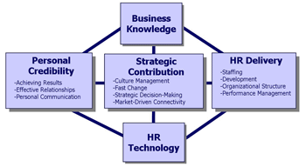
Manpower planning is the first step towards manpower management. It refers to the process of using available assets for the implementation of the business plans. It also involves the process of coordinating and controlling various activities in the organization. An effective manpower planning requires a careful assessment of the future needs of the organization. It involves the development of strategies to match the requirement of employees and availability of positions at a regional as well as a national level. Those in charge of manpower planning need to have a foresight about the business plans. They need to plan the activities for achieving business growth. They are required to estimate the business needs of the organization and plan for the resources needed to realize the business goals. We can refer to manpower planning as the process of reviewing current resources, predicting future requirements and ensuring that the demand and supply of people and skills is balanced. Manpower planning is useful for both the employees as well as the organization. We provide that consultancy to enable you to plan ahead and plan rightly.
Importance of Manpower Planning
- Planning is concerned with coordinating, motivating and controlling of the various activities within the organization.
- Planning is making a decision in advance what is to be done.
- Planning is using the available assets for the effective implementation of the production plans.

Advantages of Manpower Planning:
1. It is useful both for organization and nation.
2. It generates facilities to educate people in the organization.
3. It brings about fast economic developments.
4. It boosts the geographical mobility of labor.
5. It provides smooth working even after expansion of the organization.
6. It opens possibility for workers for future promotions, thus providing incentive.
7. It creates healthy atmosphere of encouragement and motivation in the
organization.
8. Training becomes effective.
9. It provides help for career development of the employees.

PROBLEMS IN MANPOWER PLANNING
Many manpower schemes fail completely or do not reach their full potential, mainly because the program is not implemented in the way for which it was designed. Some of the reasons for these failures are indicated below:
(a) The lack of sensitivity to problems and solutions
This important obstacle to the implementation of effective manpower planning is caused by the general apathy of line managers. Management still seems to be particularly concerned about financial and material resources and has a tendency to neglect the critical factor of human resources. Over the past few decades, productivity has increased as a result of improved technology, but any further improvement will depend, to a very great extent, upon improved manpower utilization. In this respect, management is required to show a greater respect to the role of manpower in profitability.
(b) Short term profit goals

In the short‐term there is a tendency to view manpower planning as unprofitable and too costly. This represents the traditional view that costs of personnel are overhead costs and not direct costs. It is essential that management review this problem and weigh the benefits against the costs. It is possible that this lack of concern over manpower planning could be attributed to lack of information. If information is not forthcoming, then manpower planning is a futile exercise.
(c) Lack of criteria.

The lack of information can lead directly to the absence of criteria against which to measure performance. It is not an easy task to measure human performance without the use of adequate quantitative data. It is easy to measure the depreciation of material goods, out human beings tend to appreciate with the passing of time, and this appreciation quality has never been measured. The tendency of management is to measure human beings, only in terms of their cost to the organization. Management should become aware of the fact that the evaluation of performance is long, complex, uncertain and abstract, and it is necessary that they continue their planning without the use of objective criteria.

(d) Complexity of the organization
Many organizations have increased tremendously in recent years and some appear to have difficulty in determining the exact size of the workforce. They appear to be incapable of updating the retrievable information which is essential to manpower planning. Because of the increasing complexity of organizations, it is becoming more essential to keep a track on the movements of employees, as well as all the personal details which may be of use in planning. This is where the personnel manager and his staff must exercise a keen supervision.
(e) Rapid changes

The rate of technological change causes difficulties in manpower planning. This is because, at times, it is difficult to keep up with the technical development. There is always resistance to change within an organization, but somehow this resistance must be overcome if manpower is to be utilized effectively. One possible method of overcoming this resistance to change on part of the existing staff is to introduce new employees, with new ideas from outside of the organization.
(f) Lack of communication

This problem is the oldest and most common in personnel administration. Manpower planning is now becoming a sophisticated process, only involving the use of experts, and these experts must have rapid access to accurate information

Manpower inventory
The factual information such as age, experience, education, health, appraisal reports, attitude, etc. will be noted from the records. The brief interviews with persons will help in understanding his caliber, attitude, aspirations, motives, etc.
A summary statement of information is prepared about each person and is kept ready for consultation. The information will help management to find out the suitable persons in the organization for taking up senior positions in future. This will also enable management to determine whether persons from outside will be required in future or not.
3. The next step in manpower inventory is to appraise the talent catalogue. The present and future capabilities of persons are assessed. Some scale is prepared for appraising the persons.
Besides appraisal tests, remarks about persons are also given. The remarks may relate to their talent, decision-taking ability, training required, specific limitations, etc. Besides appraisal tests, specific remarks are useful in picking up persons for future positions.
The manpower inventory will enable manager to know the present and future potentialities of all individuals and their suitability for various jobs.

Manpower Forecasting Techniques: -
Management Judgment: In this technique managers across all the levels decide the forecast on their own judgment. This can be bottom-up or top-down approach and judgments can be reviewed across departments, divisions and top management can conclude on final numbers of manpower required.
Ration-Trend Analysis: This technique involves studying past ratios, and forecasting future ratios making some allowance for changes in the organization or its methods.
Work Study Techniques: It is possible when work measurement to calculate the length of operations and the amount of manpower required. The starting point can be production budget, followed by standard hours, output per hour; man-hours required etc. could be computed.
Delphi Techniques: This technique solicits estimates from a group of experts, and HRP experts normally act as intermediaries, summarizes various responses and report the findings back to experts.
Flow Models: This technique involves the flow of following components. Determine the time required, Establish categories, Count annual movements, Estimate probable transitions. Here demand is a function of replacing those who make a transition
- The reviewed, edited, and reformatted product of the job analysis.
- Attempts to provide statements of fact that describe the job as it is.
- Acts as a job contract that conveys employee rights and establishes corresponding obligations.
Job Description

- It protects the employee and the employer by letting the employee know what is expected and what must be accomplished.
- Comes in a variety of forms.
- May be used as a substitute for / or by the job analysis.

Job Identification

- Job Title
- Status (Exempt Vs. Nonexempt)
- Job Code (Referencing System)
- Document Author, Approvals, And Date

- Job Location
- Job Grade
- Evaluation Points
- Title Of Supervisor
- Pay Range

